**Discourse Meta**

(Mentor - Aseem , Members - Ananya, Nikhil, Urvi)

**Categories and Tags**

The categories and tags on the Discourse Meta platform are as follows :

* **Categories :**

1. UX - related to UX/UI
2. Discourse BBCode
3. Bug
4. Dev
5. Theme
6. Feature
7. Installation

* **Tags :**

1. Docker (80)
2. Css (74)
3. Wordpress (44)
4. Sso (42)
5. Api (40)
6. Javascript (26)
7. UI (25)
8. Gdpr (14)
9. Pwa (10)
10. Akismet (5)
11. Dashboard (7)
12. Mobile (7)
13. Slow-sql (7)
14. Rss (6)
15. Cdn (5)
16. Ember (5)
17. iOS-app (5)
18. Statistics (5)
19. Testing (3)
20. Webhook (1)
21. Webauthn (1)
22. s3 (2)
23. Gsoc (1)
24. Sass (1)

**UI**

1. Home page :

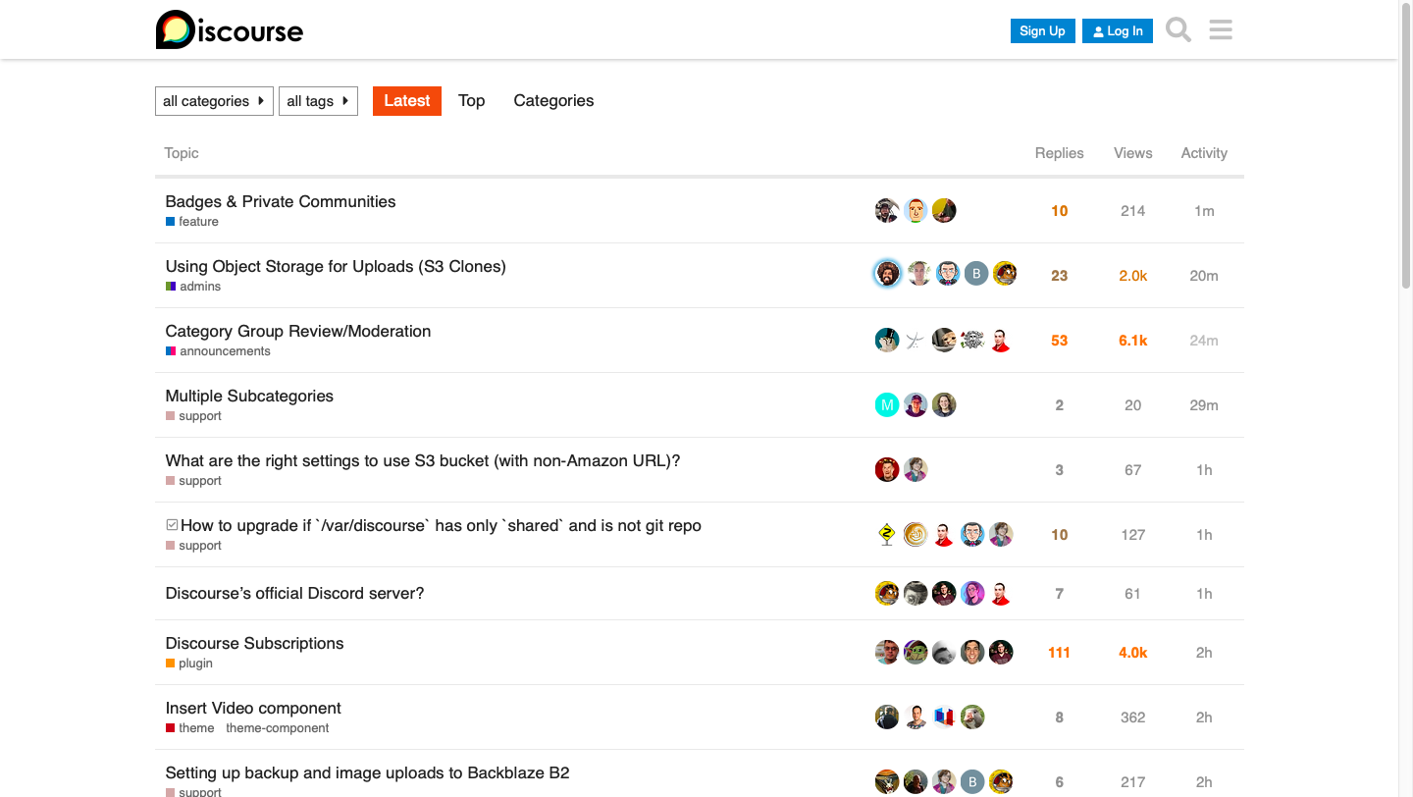

1. Categories :

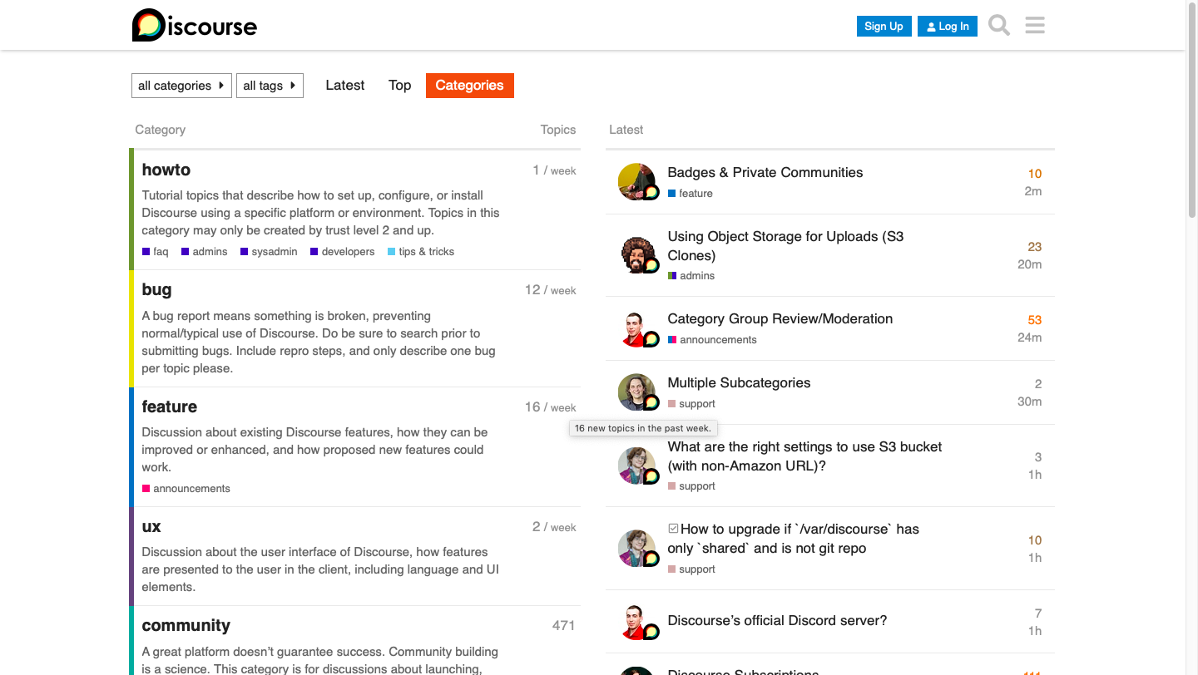

1. Tags :

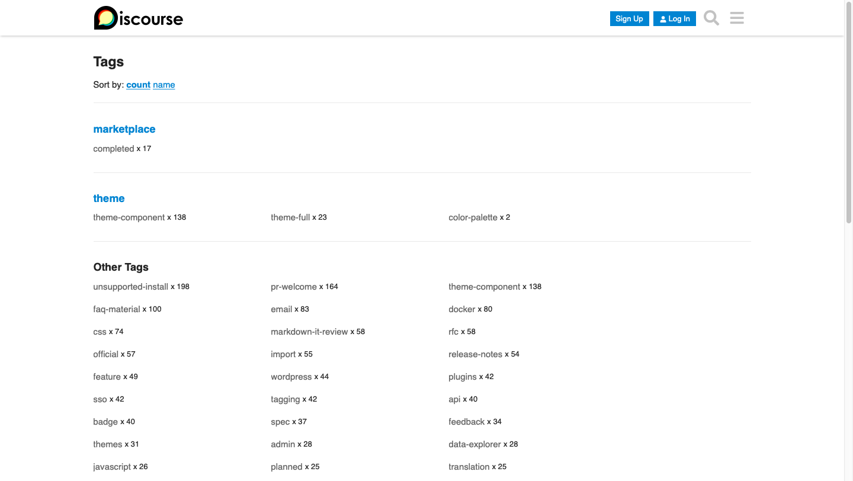

1. A random post with category - UX and tag - css :

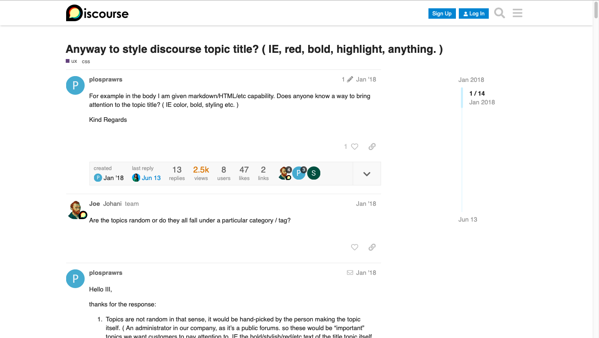

1. Few things to note :

* The timeline of a particular post can be traced similar to that of Stem-Away, i.e, there is a sliding bar to the right, as shown in the figure above.
* Old posts have their month and year of posting on the top right hand corner, while the ones belonging to this year have date and the latest ones have hours/minutes.
* The post can be liked and the link of the same can be directly shared over email, Facebook and Twitter.

**Posts**

* Title - The titles of the posts are self explanatory and informative.
* Content - The content that people are searching for is too vast in the variety of topics it covers.
* Comments/questions/replies - People are replying/commenting stuff which is relevant to the topic which is posted.

**Findings**

**Category -** Uncategorized option also available for posting on the platform but the number of topics for this category is quite less(24). In the Stem-Away forum, we have to allocate a category for every topic we are creating.

**Subcategories -** It doesn’t have any subcategories just like the Stem-Away Forum.

**Number of Posts –** It has well beyond 26000 topics(Across all the categories).

**Discrepancy**

**Tags** – On the Discourse platform, while creating a new topic, the user is not asked to enter the tags for the post while in the Stem-Away forum, it does provide an option for the same (multiple tags can be added).

**Conclusion**

Though the forum has a large number of topics covered, it has very limited categories and tags related to STEM. Most of the posts on the forum are related to bug fixes, installations and version releases. Some of the most famous topics do not seem to be included. Additionally, there are no subcategories. Thus, Discourse is not apt for web-scraping and then implementing a recommendation model for it.